Assignment 1

Task-2: Prepare a prototype design of a website in Figma which contains at least 8-10 Screen or maximum as required.

Screen:-1 Shopping Cart

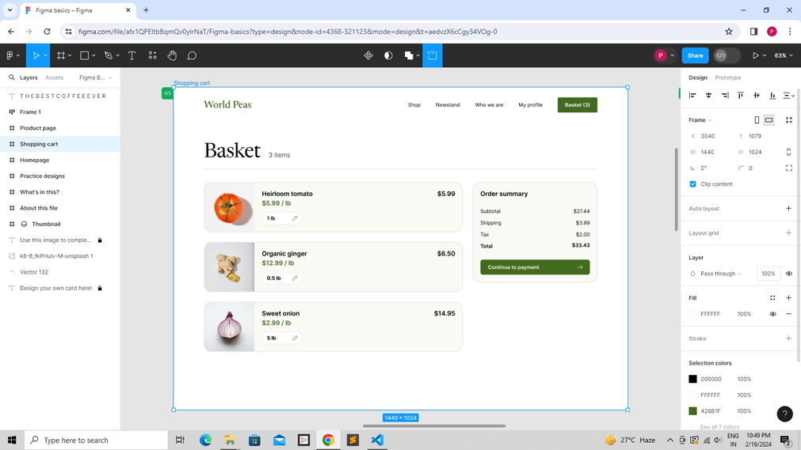

Screen:-2 Product Page

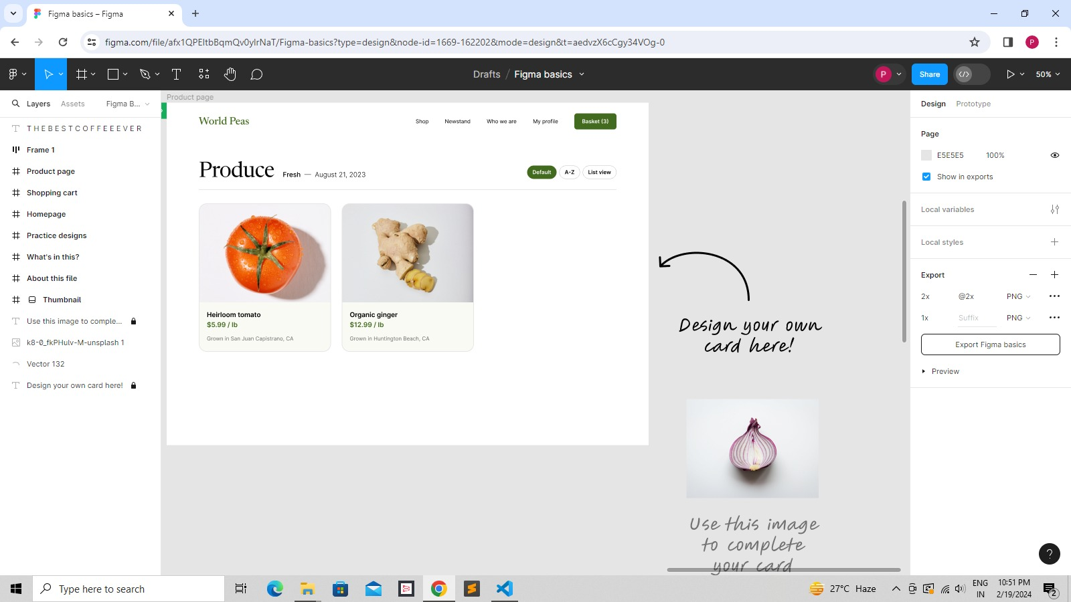

Screen:-3 Practice designs

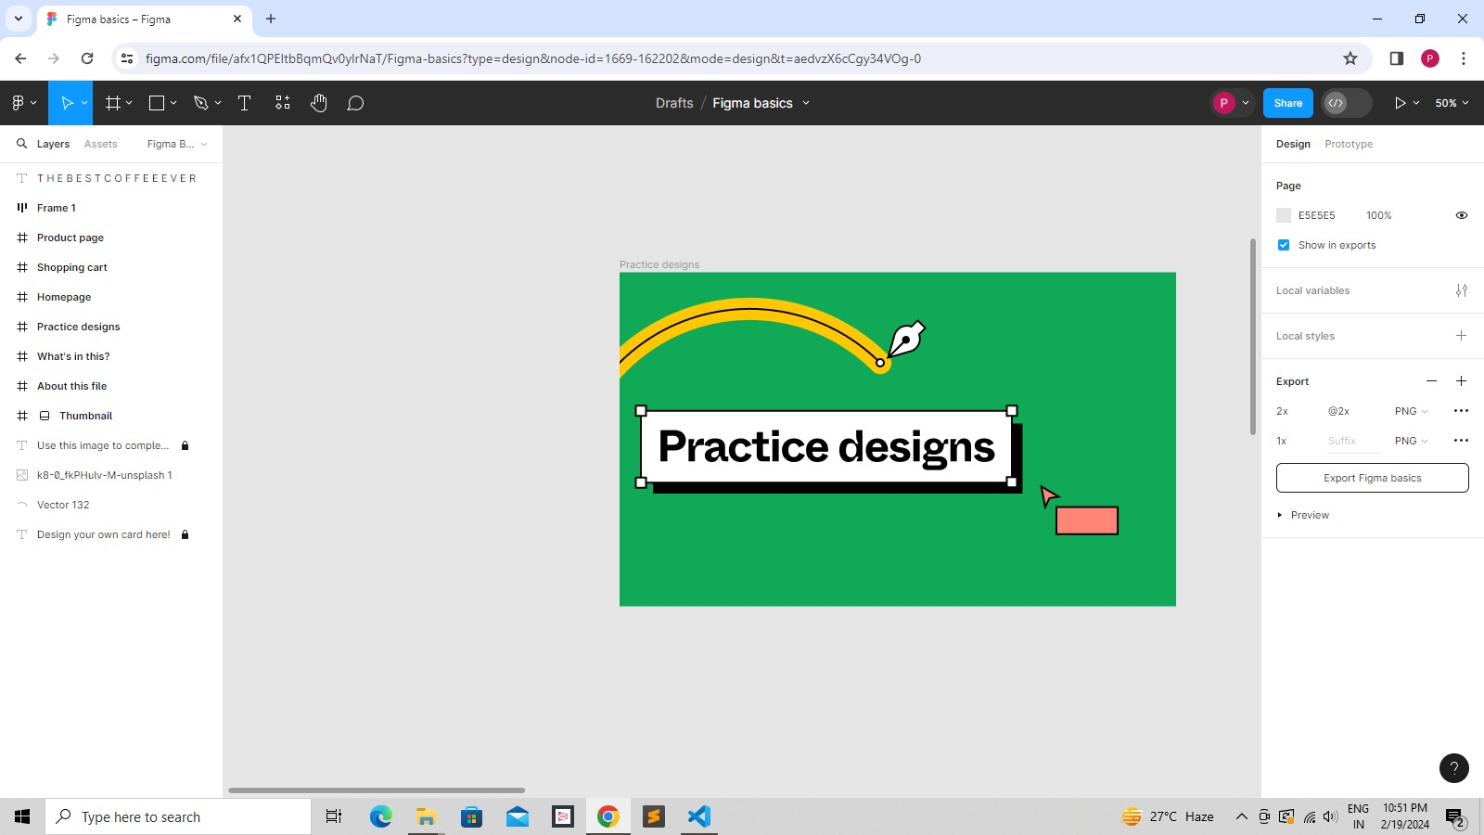

Screen:-4 Thumbnail

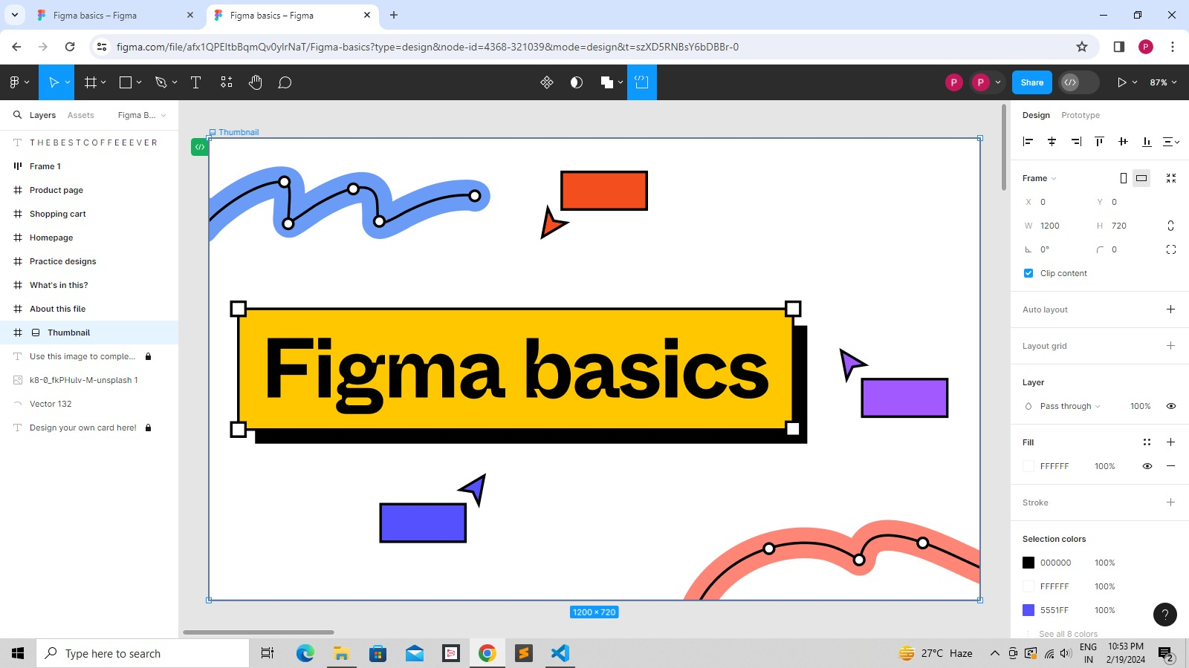

Screen:-5 Invitation Page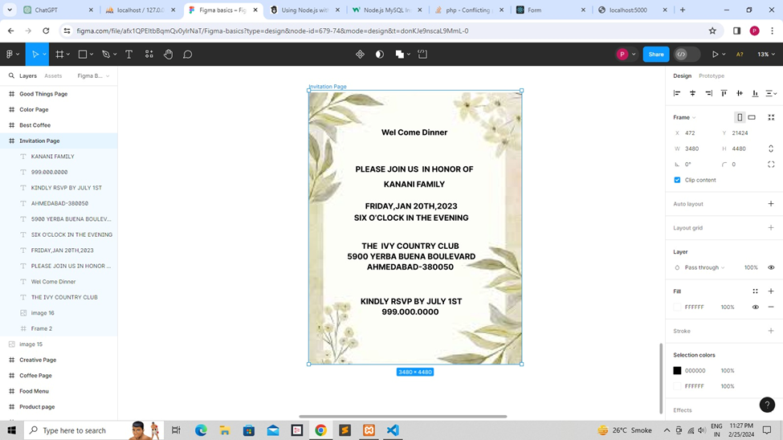

Screen:-6 What’s in this?

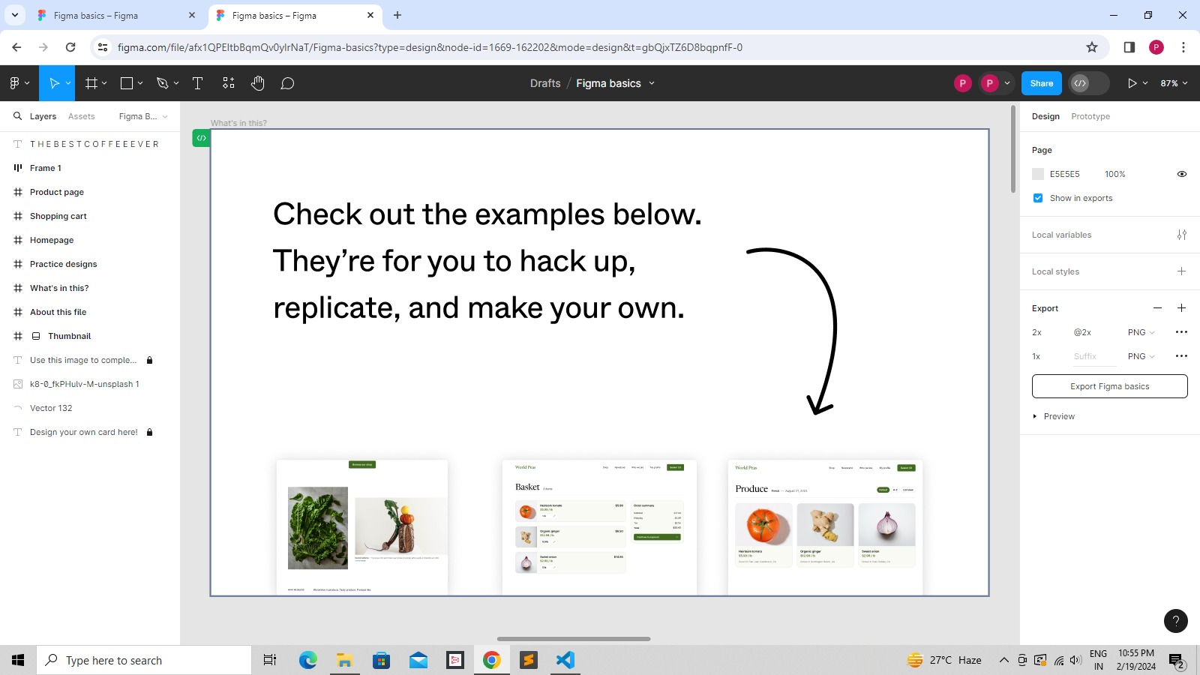

Screen:-7 Home Page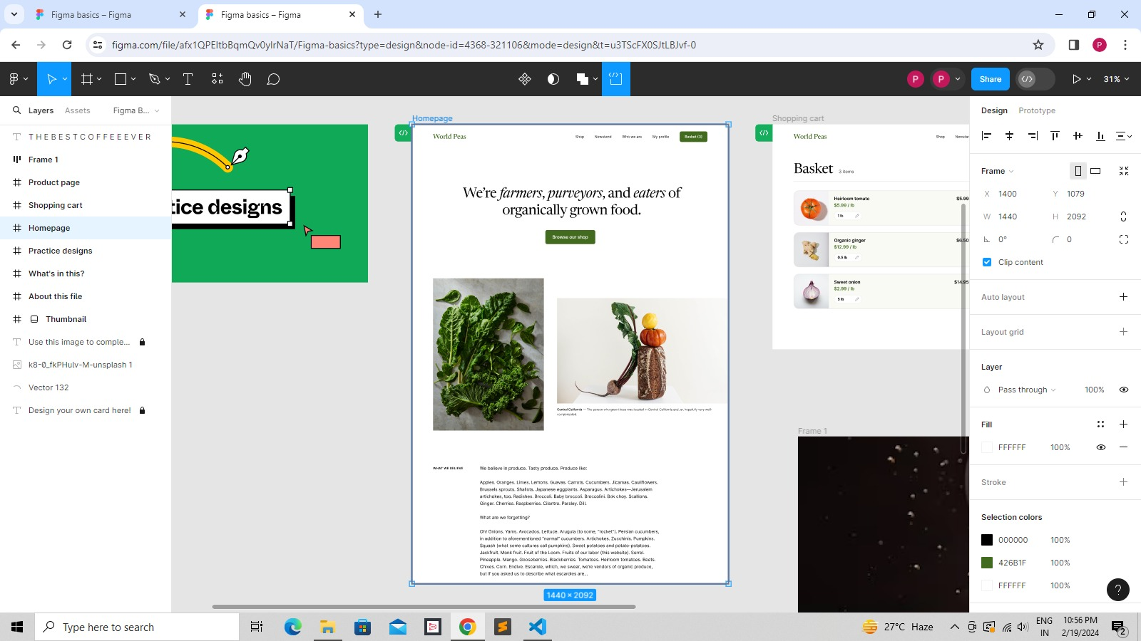

Screen:-8 Drink Page

